**DAILY ONLINE ACTIVITIES SUMMARY**

|  |  |  |  |  |  |  |  |  |
| --- | --- | --- | --- | --- | --- | --- | --- | --- |
| **Date:** | **13/06/2020** | | | | | **Name:** | **Spoorthy Balaji** | |
| **Sem & Sec** | **6th & B** | | | | | **USN:** | **4al17cs098** | |
| **Online Test Summary** | | | | | | | | |
| **Subject** | | **PAP** | | | | | | |
| **Max. Marks** | | **30** | | **Score** | | | **26** | |
| **Certification Course Summary** | | | | | | | | |
| **Course** | **Machine Learning with Python** | | | | | | | |
| **Certificate Provider** | | | **COGNITIVE CLASS. ia** | | **Duration** | | | **6hours** |
| **Coding Challenges** | | | | | | | | |
| **Problem Statement:** 3 Programs | | | | | | | | |
| **Status: Solved** | | | | | | | | |
| **Uploaded the report in Github** | | | | | **yes** | | | |
| **If yes Repository name** | | | | | <https://github.com/spoorthybalaji/Daily_Status> | | | |
| **Uploaded the report in slack** | | | | | **yes** | | | |

IA TEST

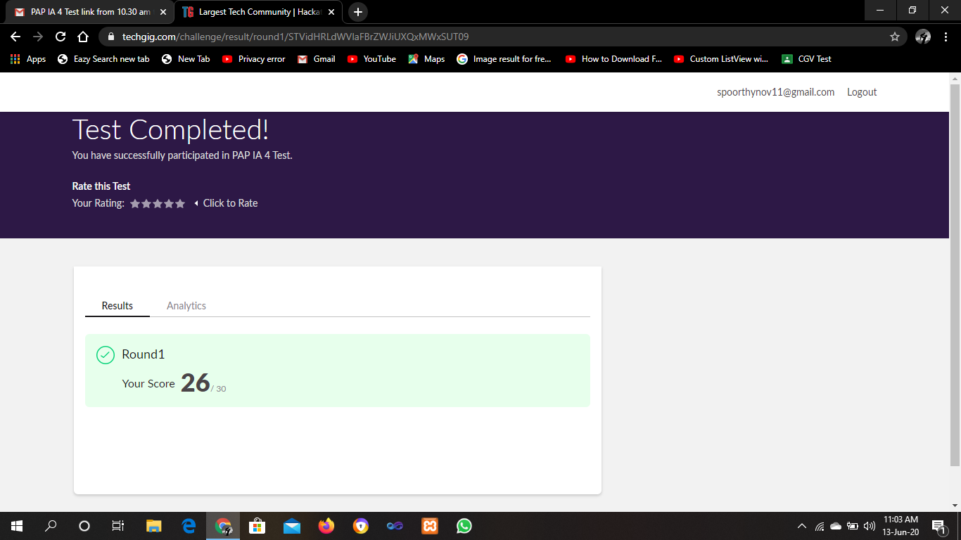

CERTIFICATION COURSE

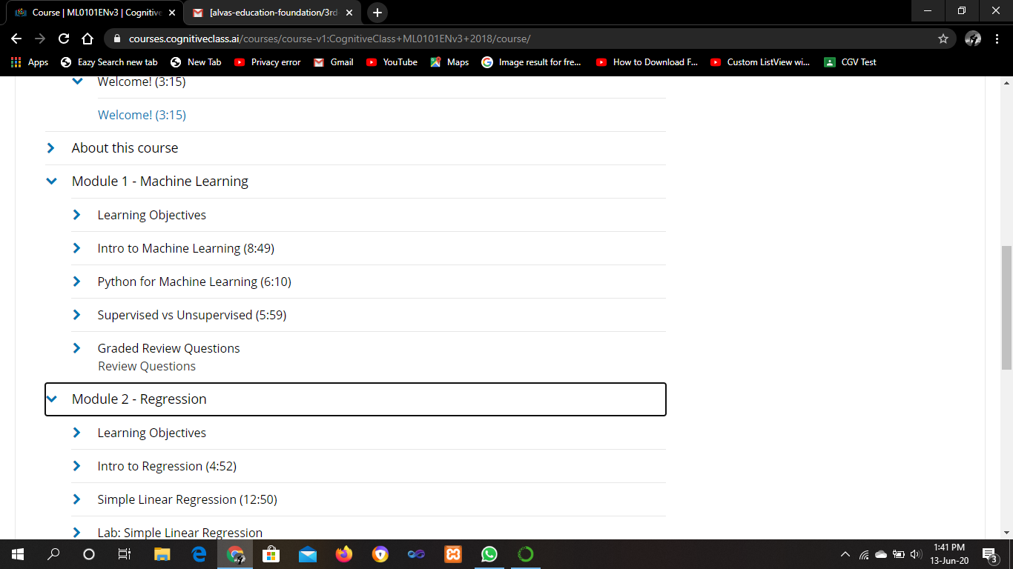

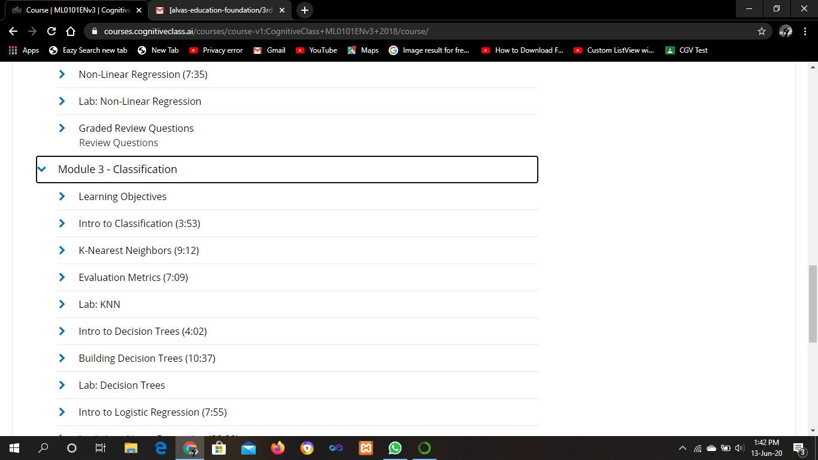

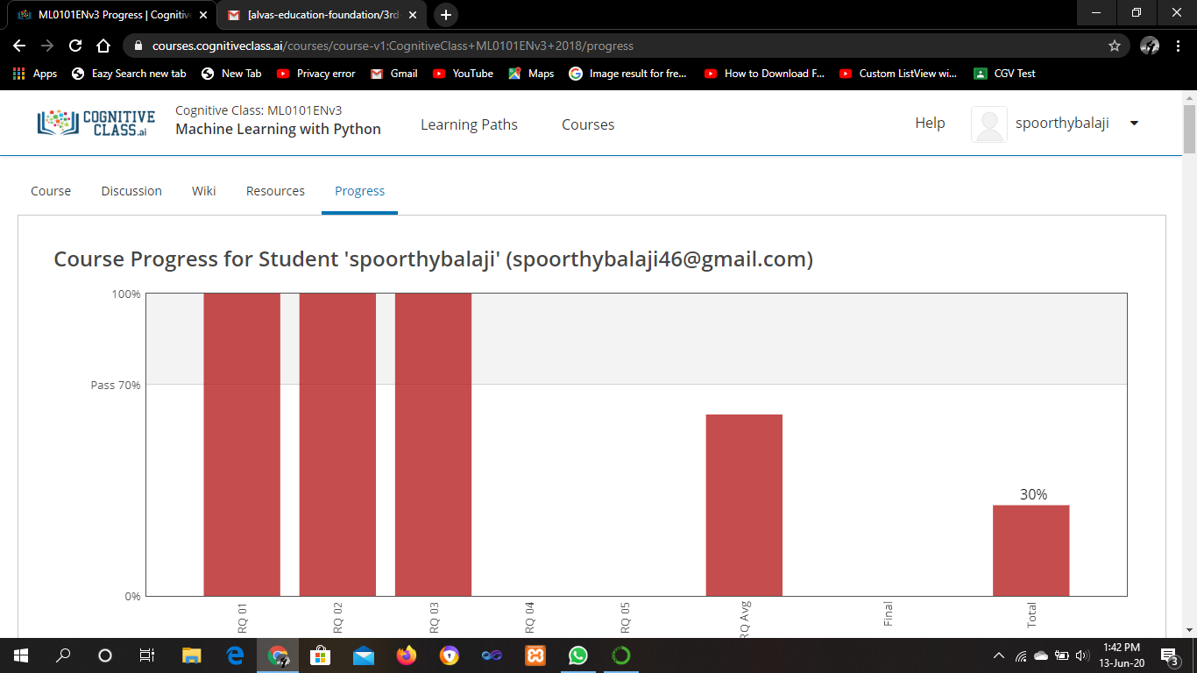

ONLINE CODING

1. **Write a C Program to calculate Electricity Bill**

**1 to 100 units – Rs. 10/- Per Unit  
100 to 200 units – Rs. 15/- Per Unit  
200 to 300 units – Rs. 20/- Per Unit  
above 300 units – Rs. 25/- Per Unit**

#include <stdio.h>

int main()

{

int unit;

float amt, total_amt, sur_charge;

printf("Enter total units consumed: ");

scanf("%d", &unit);

if(unit <= 100)

{

amt = unit * 10;

}

else if(unit <= 200)

{

amt = (100*10)+(unit-100)*15;

}

else if(unit <= 300)

{

amt = (100 * 10) + (100 * 15) + (unit - 200) * 20;

}

else

{

amt = (100 * 10) + (100 * 15) + (100 * 20) + (unit - 300) * 25;

}

printf("Electricity Bill = Rs. %.2f", amt);

return 0;

}

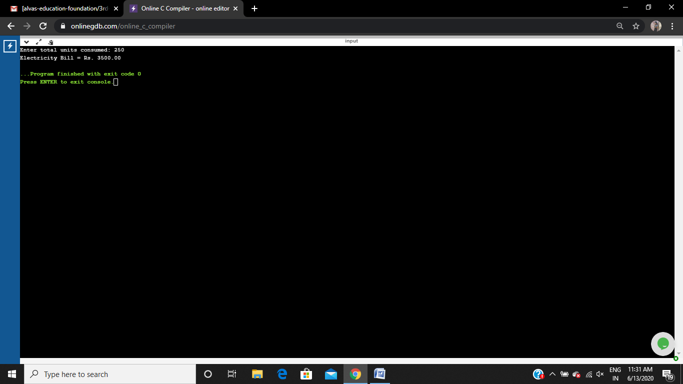

**2. How to find the first non repeated character of a given String**

import java.util.*;

public class GFG {

static final int NO_OF_CHARS = 256;

static char count[] = new char[NO_OF_CHARS];

static void getCharCountArray(String str)

{

for (int i = 0; i < str.length(); i++)

count[str.charAt(i)]++;

}

static int firstNonRepeating(String str)

{

getCharCountArray(str);

int index = -1, i;

for (i = 0; i < str.length(); i++) {

if (count[str.charAt(i)] == 1) {

index = i;

break;

}

}

return index;

}

public static void main(String[] args)

{

Scanner sc=new Scanner(System.in);

System.out.println("enter string : ");

String str =sc.next() ;

int index = firstNonRepeating(str);

System.out.println(

index == -1

? "Either all characters are repeating or string "

+ "is empty"

: "First non-repeating character is "

+ str.charAt(index));

}

}

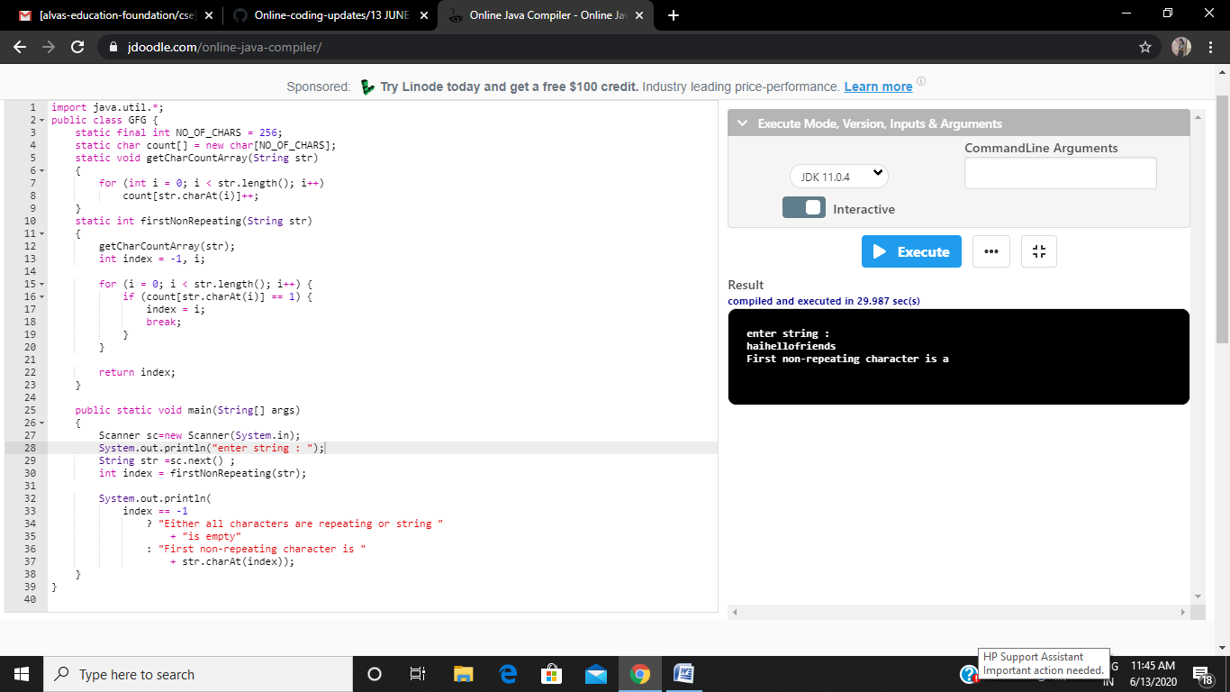

**3. Write a Java Program to determine whether a given matrix is a sparse matrix**

import java.util.*;

public class SparseMatrix

{

public static void main(String[] args) {

int rows, cols, size, count = 0,i,j;

int a[][] = new int[10][10];

Scanner sc=new Scanner(System.in);

System.out.println("enter num of rows and column:");

rows=sc.nextInt();

cols=sc.nextInt();

System.out.println("Enter " +(rows*cols)+ " Array Elements : ");

for(i=0; i<rows; i++)

{

for(j=0; j<cols; j++)

{

a[i][j] = sc.nextInt();

}

}

System.out.print("The Array is :\n");

for(i=0; i<rows; i++)

{

for(j=0; j<cols; j++)

{

System.out.print(a[i][j]+ " ");

}

System.out.println();

}

size = rows * cols;

for( i = 0; i < rows; i++){

for( j = 0; j < cols; j++){

if(a[i][j] == 0)

count++;

}

}

if(count > (size/2))

System.out.println("Given matrix is a sparse matrix");

else

System.out.println("Given matrix is not a sparse matrix");

}

}

